Using SORA for digital books, audiobooks, & read-along titles from home

- Download the SORA app from the app store onto device (it’s free!)

- Click find my school
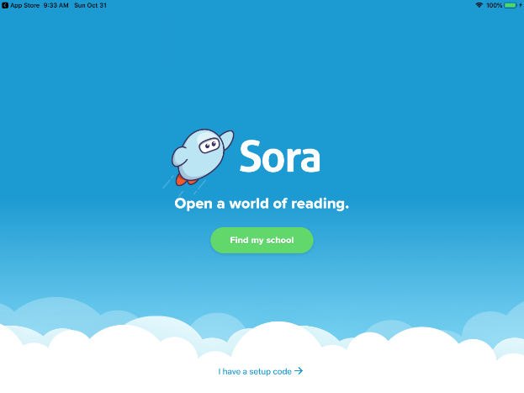

- Enter Dr. Robert Plaxton in the search bar.
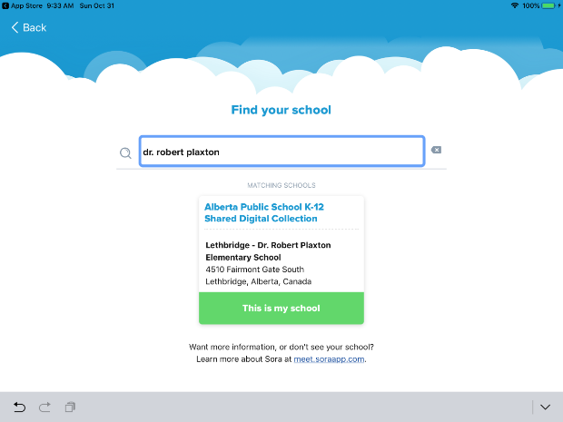

- Find Lethbridge School Division in the drop-down menu
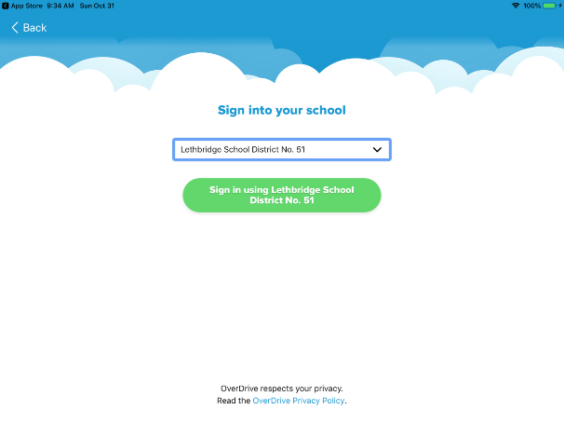

- Enter your school username and password
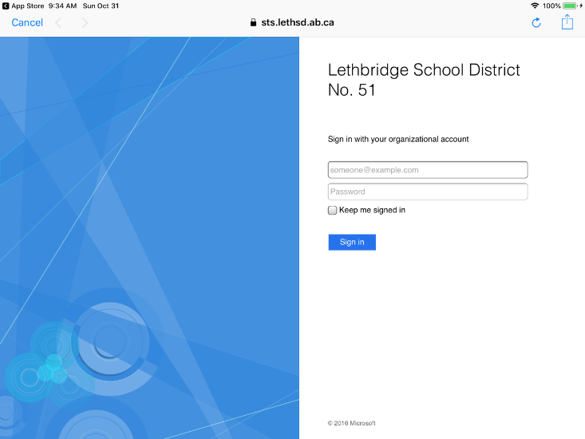

Students can check out up to 3 titles. These titles will stay on a device for 3 weeks (then they magically disappear). Students can renew a title if there are no holds on the title. Students can place a hold on a title (there will be an approximate date when the title will become available). Students will be notified by email when the title is available. When finished with a title, students are encouraged to return the title promptly so that others can enjoy it.

